Introduction to Amazon Elastic Block Store

Task 1: Create and attach an EBS volume to an EC2 instance

In this task we enter a name for the two volumes that are not named, Boot_Vol_1 and Boot_Vol_2 and we take note of the Availability Zone we will need it for creating the other resources later on.

Task 1.2: Create an EBS volume

In this task we create a new Amazon EBS volume with the following values:

Volume Type – General Purpose SSD (gp3)

Size – 30GB

IOPS – default

Throughput – 250

Availability Zone – in my case us-west-2b

Encryption – we tick the box and select default for KMS key from the dropdown

Add tag – Key(Name) and Value(New_App_Main)

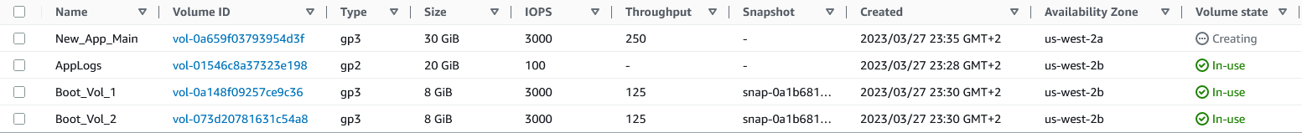

Task 1.3: Attach EBS volume to an EC2 instance

In this task we attach the EBS volume that we created to the instance New_App. Then we go to the Storage tab of the instance to examine the volumes.

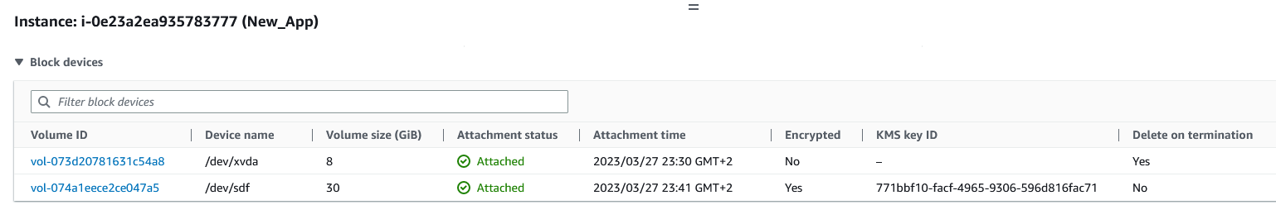

Task 2: Create and configure a file system on an attached EBS volume

In this task we create a Linux ext3 file system on the EBS volume and create a mount point. We open a secure connection to the New_App EC2 instance from the Session Manager, and run the commands in the terminal.

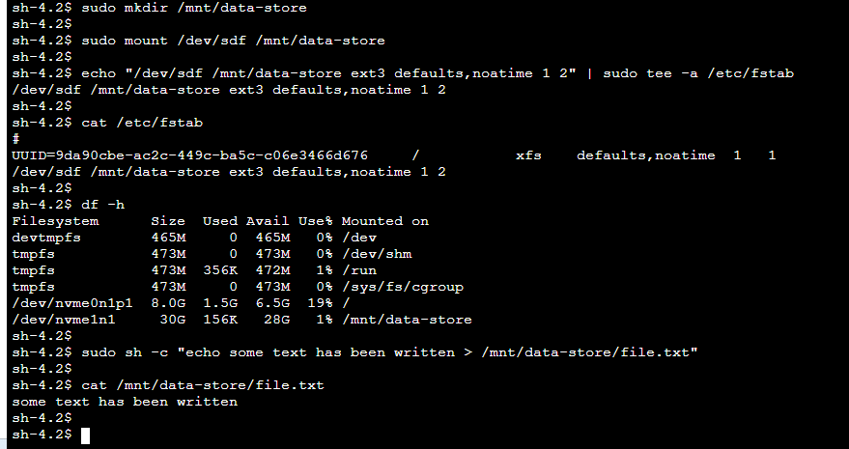

Task 3: Modify the EBS volume size and expand the file system on the volume

Task 3.1 Modify the size of an existing EBS volume

In this task we modify the size of the EBS volume that we created in the first task. From the Actions drop-down list we choose Modify Volume and we change the size to 50GiB.

Task 3.2: Expand the volume of your system

After modifying the volume, we now need to extend the system partition. We go back to our terminal from the previous task and resize the partition.

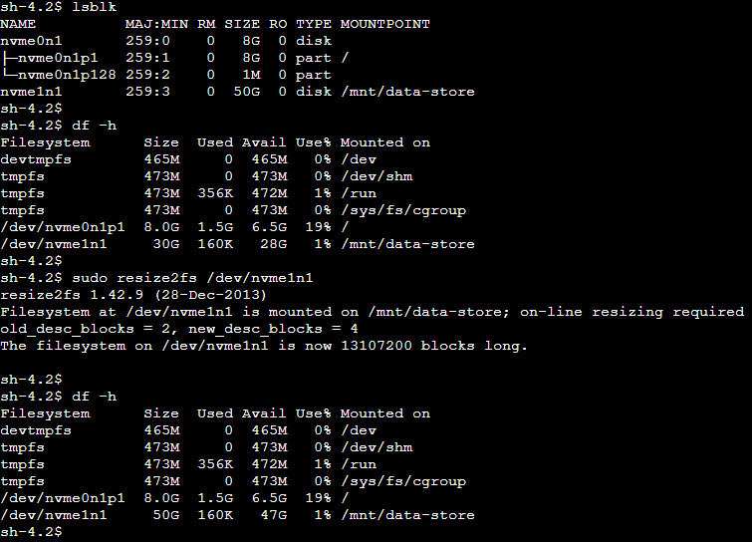

Task 4: Modify the EBS volume type and provisioned performance for an existing application

In this task we will modify the EBS volume type and provisioned performance for the EBS volume attached to the EC2 instance named Existing.

We go to the Actions drop-down list and choose Modify Volume.

Here we change the following settings:

Volume Type – General Purpose SSD (gp3)

IOPS – 6000

Throughput – 250

We leave the rest to default and apply the modified settings.

Task 5: Configure a snapshot for an existing EBS volume

In this task we create a snapshot for the volume that we created. For this we go to Actions and choose Create Snapshot. We give a description for the snapshot, in this case “Snapshot of App_Main” and Add Tag with Key:Name / Value: App_Main_Snap.

We can now view the snapshot under Elastic Block Store – Snapshots.



Task 6: Restore an EBS volume from an existing snapshot

In this task we create a new volume from the snapshot we created in the previous task.

We navigate to the Snapshots page and select our snapshot. On the Actions menu we choose Create Volume. We select General Purpose SSD(gp3) for Volume Type and increase the Size to 55GiB.

We add a tag with Key:Name / Value: Restored_App_Main and create the volume.

After it is created, we can now Attach the volume under the New_App instance. Now as we did previously, we need to create a mounting point for the restored volume from the terminal.

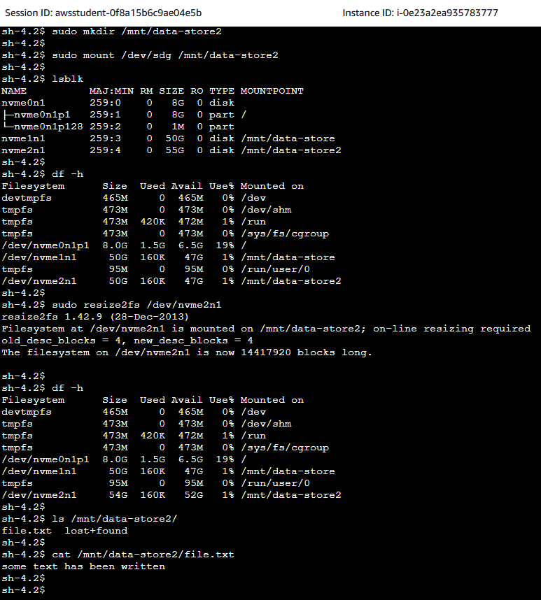

Challenge task

In this task we create a new EBS volume with the following settings:

Name: New_App_Performance

Volume type: Provisioned IOPS SSD (io2)

Size: 50 GiB

IOPS: 20000

Availability Zone: same as previously

Encryption: Enabled



After the volume is created, we attach it to the New_App EC2 instance. We can now connect and open Session Manager terminal in order to mount the volume to the instance and create a file system on it.

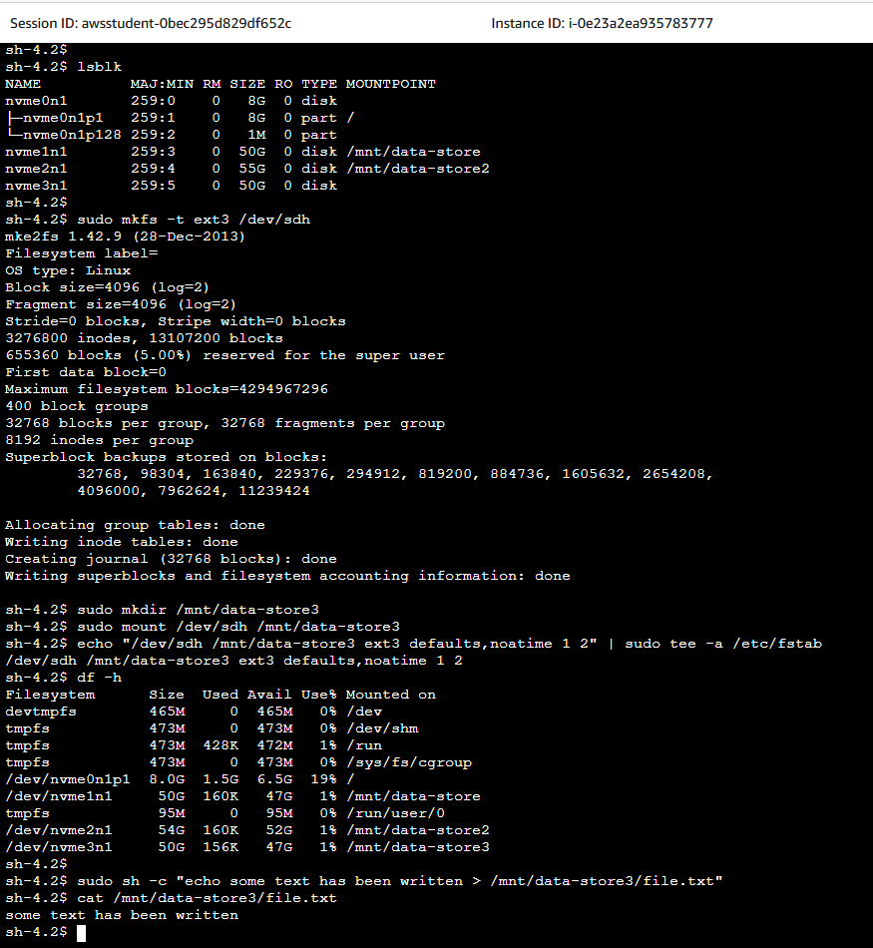

As a last step we create a snapshot of the new volume.

